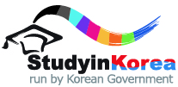
2021 KOREA-JAPAN JOINT HIGHER EDUACTION
STUDENT EXCHANGE PROGRAM
FORM 2 PERSONAL STATEMENT

(Please briefly introduce yourself and give reasons why you want to participate in this program.)
※ One page narrative essay (A4 size, one sided)
※ Typed, not hand written.
※ Should be written by the applicant.
※ Should be written in either Korean or English.

